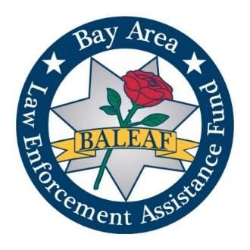
BALEAF DONATION / SUPPORT
(Bay Area Law Enforcement Assistance Fund)
P.O. Box 31764
San Francisco, CA 94131-0764
Phone No.: 415-837-0875
Fax No.: 415-392-6273
Email: bayareale1025@gmail.com
“We hope that you never need us, but we're here if you ever do.”

Name: _________________________________________________________________________

Address: ______________________________________________________________________

Company: _______________________________________________________________________

Contact Number: _(c)___________________________________(t)________________________

Email: _________________________________________________________________________

______ I am making a donation in the amount of $______. My check / money order is enclosed.
______ I am making a donation in the amount of $_____. I will send the funds via bank wire transfer.

To our supporters:
Please keep a copy of this form for your tax records. BALEAF is a 501(c)(3) nonprofit charity with IRS Tax Identification #91-2006597.

If you are a corporate sponsor, please email a copy of your logo, website address, and tag line to our President, Fabian Brown, at bayareale1025@gmail.com. Your information will be included in our sponsorship webpage.

If you need additional information, please email or telephone us.

